***Introduction***

In this website we display normally all type of toys. So people can use that site and get information what they want.

Our website online toys shopping is used to purchase toys and view toy’s information.

In this site if user have purchase any toy then first register and then they can purchase items.

It provides the basic information about toy.

***Project profile***

* Project Name : online toy shelling
* Developed by : Mansi J. Mehta & Harshita B. Rathod

* Platform : windows 10
* Front End tool : ASP.NET
* Back End tool : SQL SERVER
* Editor(Tool) : Visual Studio 2008
* Completion Time : 12-2-18
* Guide by : MR. Prakash Gajera

***Project abstract***

The online toy shelling requires a system that will handle all the necessary and minute details easily and proper database security accordingly to the user.

They requires software which will store database about item. The main objective

Of the project is to design and develop a

User friendly system.

Provides security to data by using login and password storing information of user items etc.

Check validity of information provided by user storing information of user according their id.

***Strategies [sdlc]***

The proposed CMS will go through the following stages of development in its software development life cycle. Here as seen “waterfall” model of development is adopted

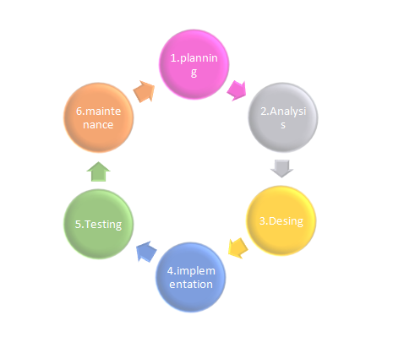

***Analysis***

*A toy is an item that is used in play, especially one designed for such use.*

*Different materials like wood card, paper, and plastic are user to make toys. Many item are designed to serve as toys, but goods produced for other proposed can also be used.*

*For instance , a small l child may fold an ordinary piece of paper into an*

*Airplane shape and “fly it”*

* *REQUIREMENT ANALYSIS*

*Our project title is online toy shelling. Our project is providing games and child toys Relate website. Requirements analysis is done in order to understand*

*The problem the software system is to solve.*

*The goal of the requirements activity is to document the requirements*

*In a software requirements specification document.*

*There are two major activities in this phase: Problem Understanding*

*Or Analysis and Requirement Specification. In problem analysis, the aim is understand the problem and its context, and the requirements of the new system that is to be developed.*

*Once the problem is analysed and essentials understood, the requirements must be specified in the requirements specification document. The requirements specification document.*

*The requirement document must specify all functional and Performance requirements; the formats of inputs and output; and all design constraints that exist due political, economic, environmental, and security reasons.*

* *CURRENT SYSTEM*

*When website related concept was not out come in market, peoples are used too many websites like flipkart and amazon other material for getting play.*

*While you are reading any materials or books at that time if you get some Questions or confusion, there you need to meet someone else to sold out your debuts so this processes time consuming.*

*Here on our website, many category in toy every time for sold out your problems.*

*I try to remove maximum disadvantages of existing system. Our website‘s aim is*

*To save users time and in very less time they can increase toys. Our website provide admin panel.*

* *PROPOSED SYSTEM*

*To provide an interactive and user-friendly website to the user.*

*To provide a high-performance system that works much faster.*

*To provide a simple and consistent output, which meets user’s requirements.*

*To provide a simple as well as economical system.*

* COST ESTIMATION

|  |  |
| --- | --- |
| **Charges name** | **Charges** |
| **Template** | **1700Rs** |
| **Web Development** | **5000Rs** |
| **Designing** | **1000Rs** |
| **Other** | **900Rs** |

* PERT CHART

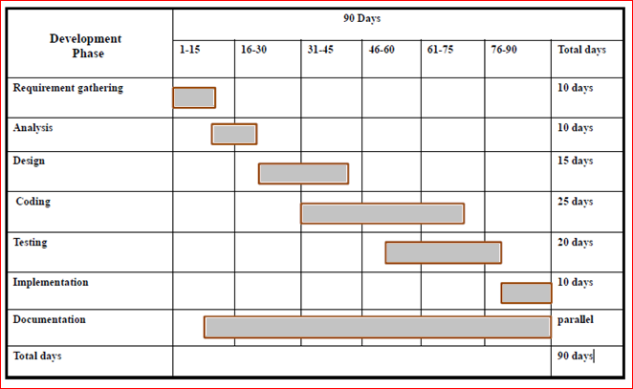

ABOUT FRONT-END

**ASP.NET**

*ASP.NET is the next generation of ASP, but it’s not an upgraded version*

*Of ASP.*

*ASP.NET is an entirely new technology for sever side scripting. ASP.NET is*

*A part of the Microsoft .NET framework, and a powerful tool for creating*

*Dynamic and interactive web pages.*

*ASP.NET is a web application framework development marked by Microsoft*

*To allow programmers to build dynamic web site, web application and*

*Web services.*

*It was first released in January 2002 with version 1.0 of the .NET, framework, and it is success to Microsoft’s active sever page (ASP) technology. ASP.NET is built on the common language runtime (CLR), allowing programmer to write ASP.NET code using any supported. .NET language.*

*ASP.NET is a framework for building web applications. It is just one part of the . .NET Framework.*

*Middle and back end parts of an ASP.NET application would be created using. .NET framework as well.*

ABOUT BACK-END

**SQL SERVER**

*SQL Server is a powerful multi-user DBMS. It can be used to store and manipulate large amount of information and automate repetitive tasks, such as marinating an inventory and generating invoices by using data input forms can be easily developed. Data can be processed and created meaningful reports.*

*Data in SQL Server organized in form of table. Within a table records are arranged accordingly to a common reference value known as primary key. The value in the key fields is different for every record and thus helps in uniquely identifying records.*

*A combination of two or more fields can be used as a primary key. Such a combination is called a composite key. Since a value in one table can be replicated across other table there should be a way to maintain a relationship is implemented through the concept of foreign key. A foreign key in a table is field, which links that table to another table; in the SQL Server we can retrieve the data from two tables in one table through join query*

*DBMS is used by various users for various purposes. Some may involve in retrieving data and some may involve in backing it up. Some of them are described as follows:*

* ***Administrators****: A bunch of users maintain the DBMS and are responsible for administrating the database. They are responsible to look after its usage and by whom it should be used. They create users access and apply limitation to maintain isolation and force security. Administrators also look after DBMS resources like system license, software application and tools required and other hardware related maintenance.*
* ***Designer****: This is the group of people who actually works on designing part of database. The actual database is started with requirement analysis followed by a good designing process. They people keep a close watch on what data should be kept and in what format.*
* ***End Users****: This group contains the persons who actually take advantage of database system. End users can be just viewers who pay attention to the logs or market rates or end users can be as sophisticated as business analysts who take the most of it.*

Feasibility study

* *ECONOMIC FEASIBILITY*

Economic analysis is most frequently used for evaluation of the effectiveness of the system. More commonly known as cost/benefit analysis the procedure is to determine the benefit and saving that are expected from a system and compare them with costs, decisions is made to design and implement the system.

This part of feasibility study gives the top management the economic justification for the new system. This is an important input to the management the management, because very often the top management does not like to get confounded by the various technicalities that bound to be

Associated with a project of this kind. A simple economic analysis that gives the actual comparison of costs and benefits is much more meaningful in such cases.

In the system, the organization is most satisfied by economic feasibility.

Because, if the organization implements this system, it need not require any additional hardware resources as well as it will be saving lot of time.

* *TECHNICAL FEASIBILITY*

Technical feasibility centers on the existing manual system of the test management process and to what extent it can support the system. According to feasibility analysis procedure the technical feasibility of the system is analyzed and the technical requirements such as software facilities, procedure, inputs are identified.

It is also one of the important phases of the system development activities.

The system offers greater levels of user friendliness combined with greater processing speed. Therefore, the cost of maintenance can be reduced. Since, processing speed is very high and the work is reduced.

In the maintenance point of view management convince that the project is operationally feasible.

* *BEHAVIOURAL FEASIBILITY*

People are inherently resistant to change and computer has been known to facilitate changes.

An estimate should be made of how strong the user is likely to move towards the development of computerized system. These are various levels of users in order to ensure proper authentication and authorization and security of sensitive data of the organization.

Software requirement & specification

* Software& Hardware requirement
* Software Requirements
  + Frontend tool

ASP.NET

* + Backend tool

SQL server

* + Server

IIS

* + Other software

Visual studio 2008

Windows 10

* Hardware Requirement
  + Processor i3 processor
  + R.A.M. 2GB
  + Hard-disk space 500GB

**Data Dictionary**

The data dictionary of any system is an integral component of structure analysis, since data flow diagrams by themselves do not fully describe the subject under investigation about the system.

A data dictionary is a catalog – a repository – of the elements in the system. These elements center on data and the way they are structured to meet user requirements and organization needs. This step of creating a data dictionary is simultaneous with the process of making data flow diagram. Here all the data fields in their respective tables are allotted so as to access these data in the system. The data tables are created in a back-end tool my sql etc…. Here in the online toy joy shelling we are using tables created in MySQL, as it is the back-end tool used in the system.

**Database: toy joy**

***Admin***

Description: - This table is used to admin login.

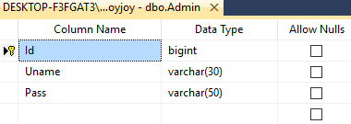

***Cart***

Description: - This table is used to cart.

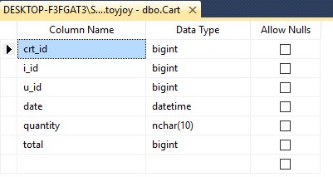

***Category***

Description: - This table is used to store category.

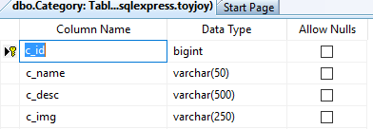

***Sub Category***

Description: - This table is used to store subcategory.

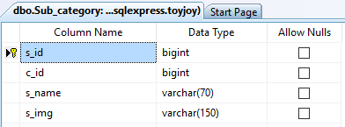

***Feedback***

Description: - This table is used to show feedback.

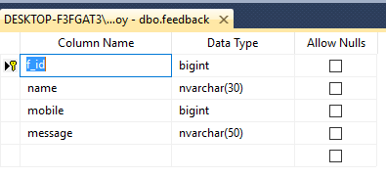

***Item***

Description: - This table is used for Item.

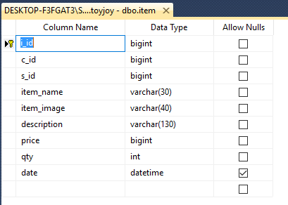

***User***

Description: - This table is used for registration.

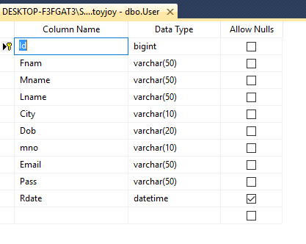

***Checkout***

Description: - This table is used to checkout process

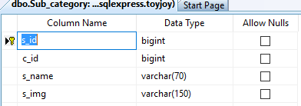

***Order***

Description: - This table is used for order.

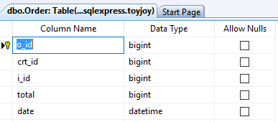

**Dataflow Diagram (0 and 1 level)**

A **data flow diagram** (**DFD**) is a graphical representation of the "flow" of data through an information system

**Paste here Data Flow Diagram (0 and 1 Level)**

**1) Process: - Here flow of data is transformed. E.g. Forms Distribution, Preparing Merit list, etc**.

**2) External Entity: -A source or destination of data, which is external to the system. E.g. Student, Committee etc.**

1. **A data flow: -It is packet of data. It may be in the form of document, letter etc.**
2. **Data store: -Any store data but with no reference to the physical method of storing.**

CONTEX LEVAL DFD (0)

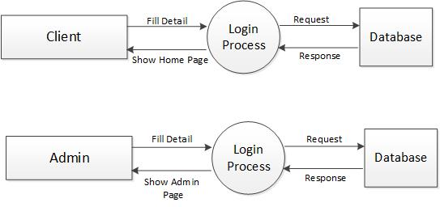

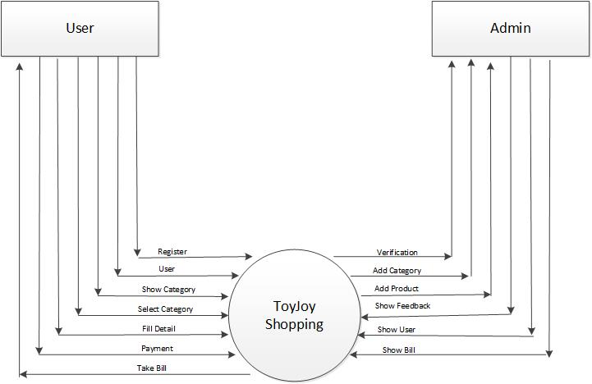

FIRSTLEVAL DFD(1)

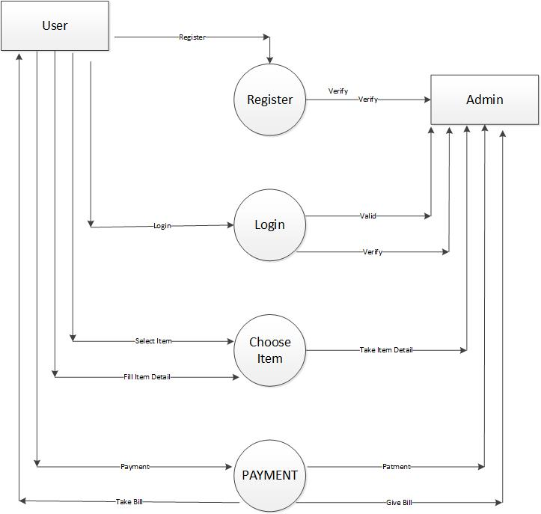

Testing & Implementation

* **Testing Plan:-**
* The main purpose of testing is to find the error and bugs.
* To ensure that during operation the system will perform as per specification.
* To make sure that the system meets user’s requirements during operation.
* To see that the when correct inputs are fed to the system, then the outputs are correct.
* Test the system using the wrong input and check the it will give an error or not.
* **Testing Strategy:-**

We test the system through the following techniques.

* Data flow testing
* Functionality testing
* Unit testing
* Condition testing
* Constraints testing

**Testing Method:-**

We adopted the integration testing and unit testing strategies. We divided all the two main module of our project in the units, prepared them individually and then tested them as per their working strategy. After the individual testing of each such module, we integrated them module wise and tested the whole modules individually.

* **Testing Cases:-**

|  |  |  |  |
| --- | --- | --- | --- |
| **NO.** | **Description** | **Expected Value** | **Status** |
| 1 | Testing user registration form must enter id | Display error message | Ok |
| 2 | Testing user name at registration, if user name is not registered. | Allow | Ok |
| 3 | Testing the login form with valid user name and password. | Allow access | Ok |
| 4 | Testing at upload image, if admin select wrong file rather than jpg. | Not allow | Ok |

**Implementation Environment**

* The environment used in this project for multi-user and with GUI environment.
* We work on the project by observing the following rules.

1. Give the proper name to each variable.
2. Give new name to each variable to avoid the name collisions.
3. Do not rename the variable name once name is assign.

**Screen short**

**Home page**

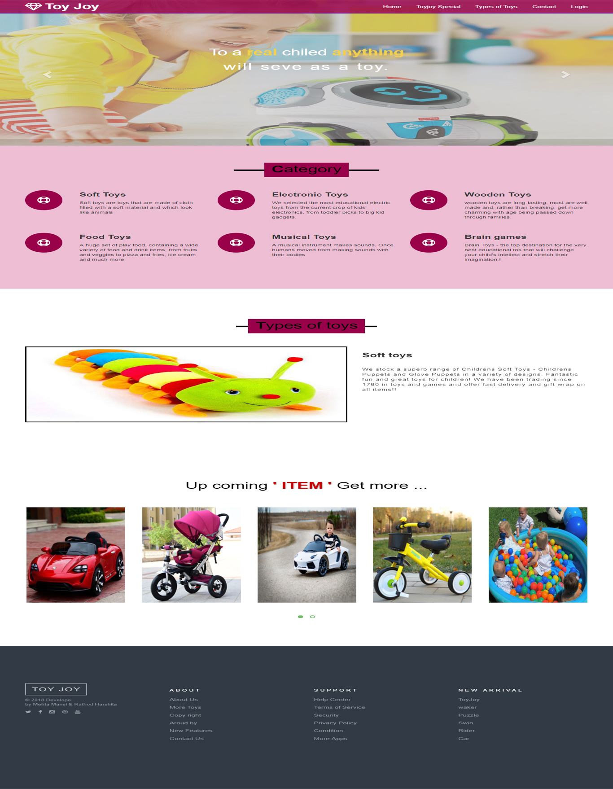

**Toy joy special toys**

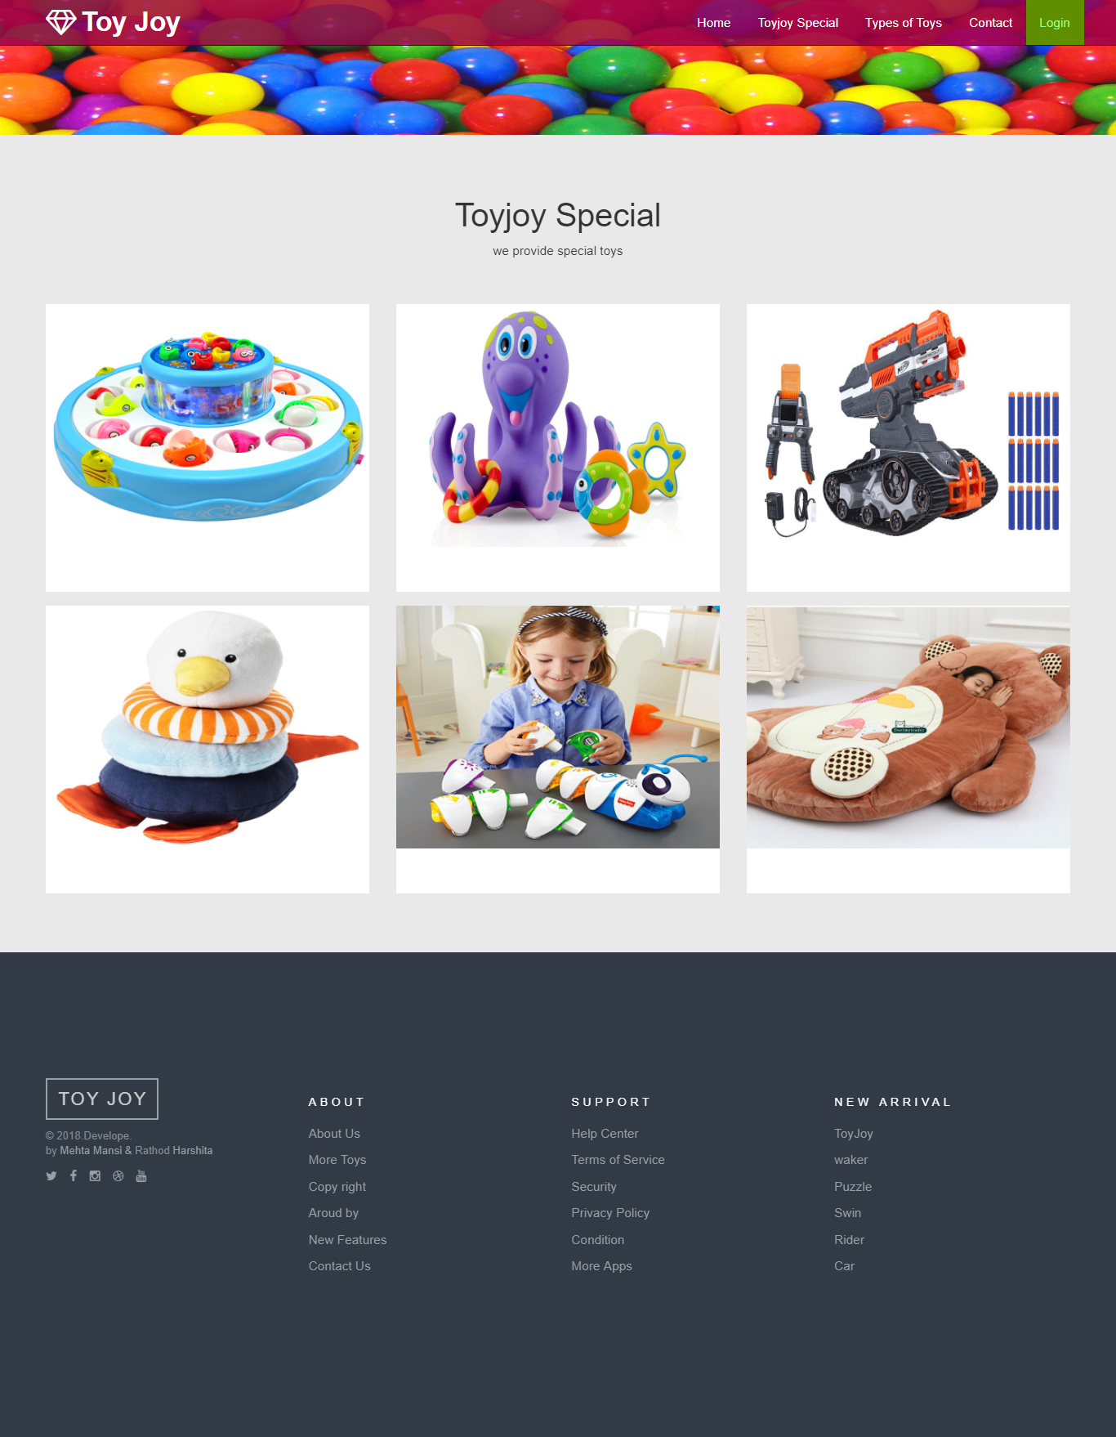

**Types of toy joy**

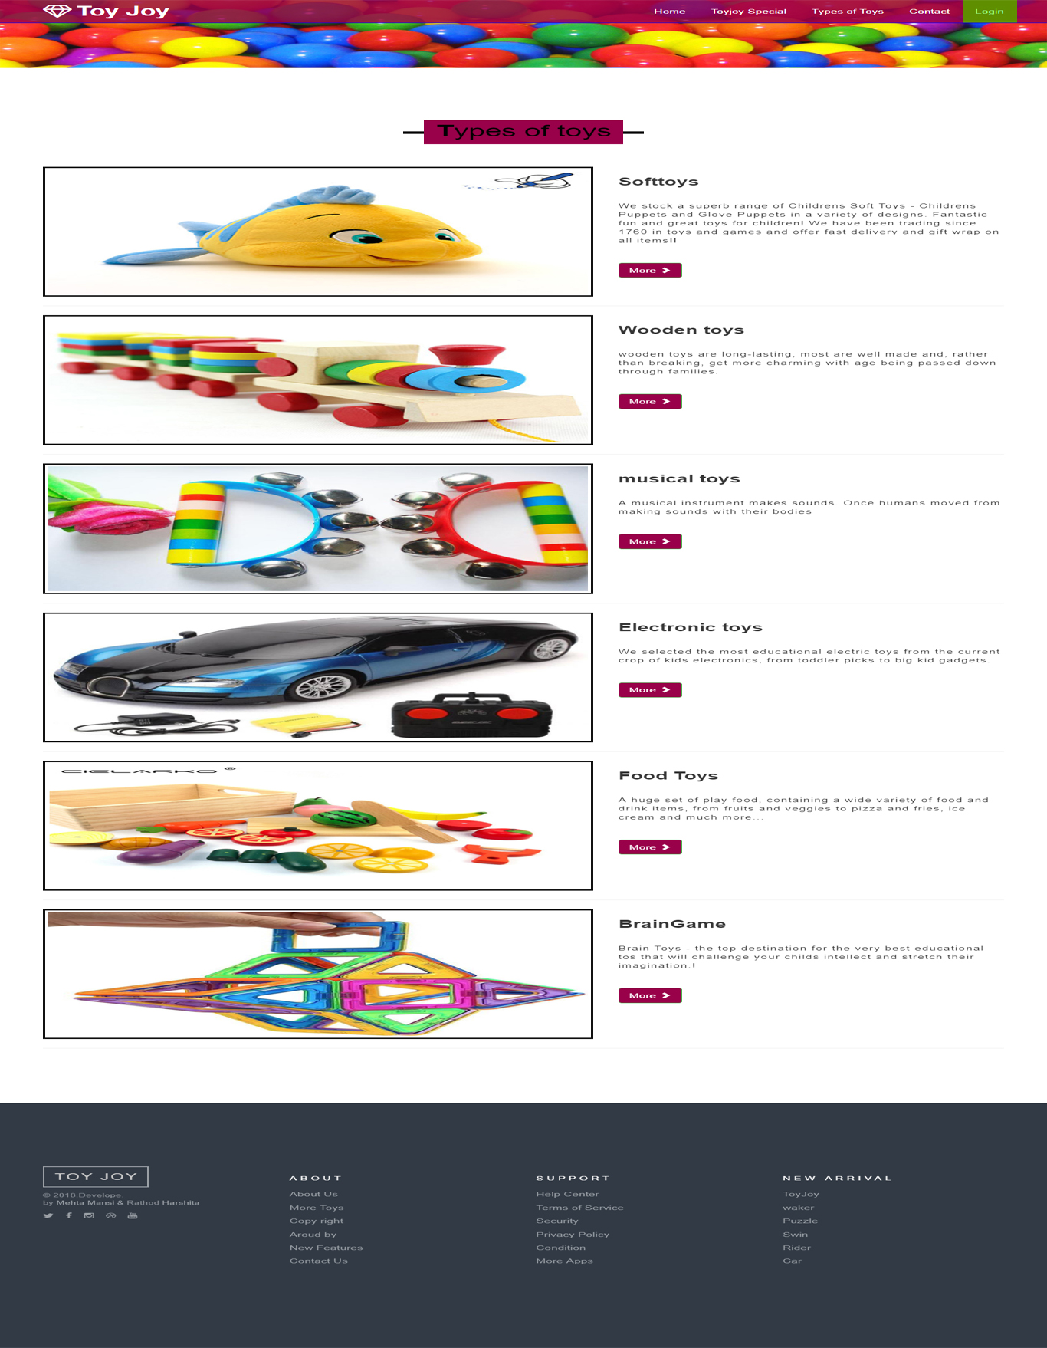

**Toy joy soft toys**

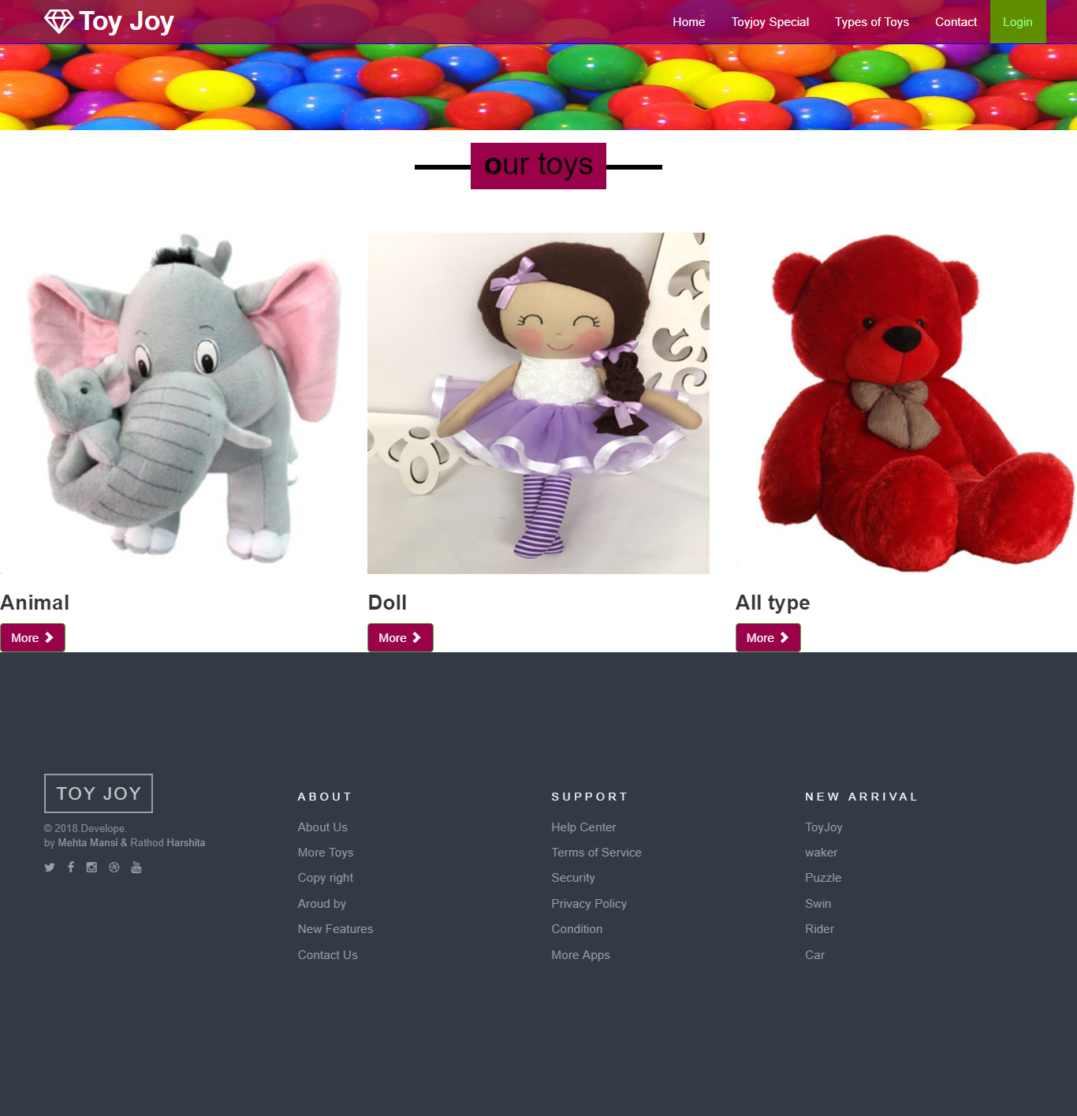

**Toy joy wooden toys**

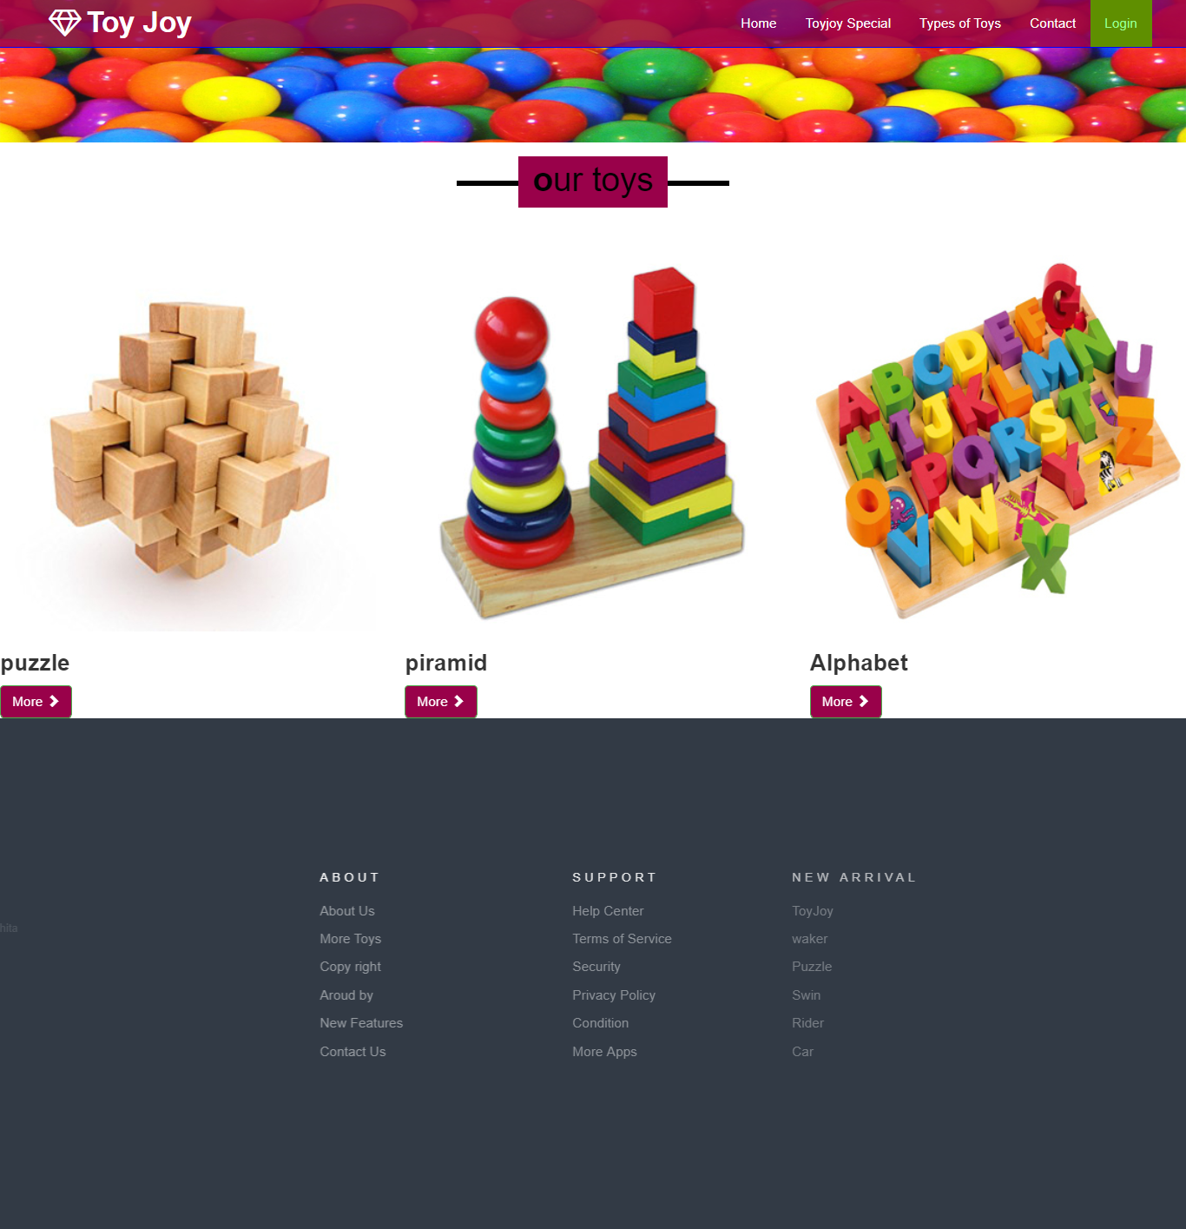

**Toy joy music toys**

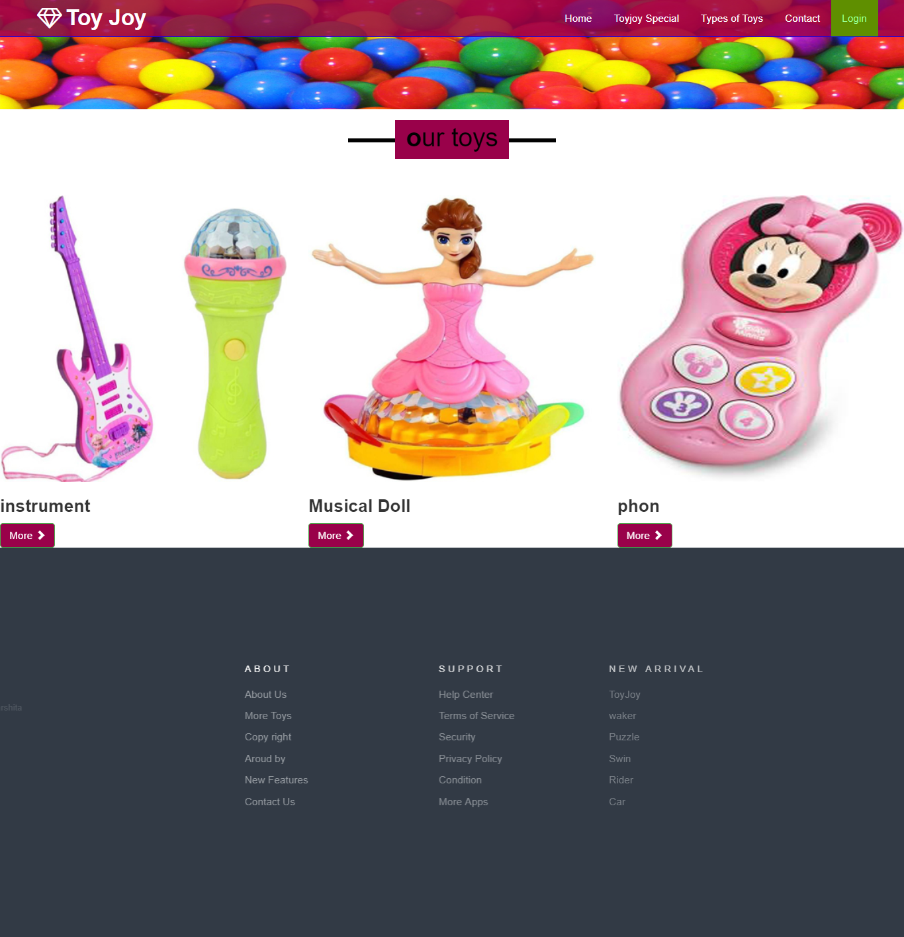

**Toy joy electronic toys**

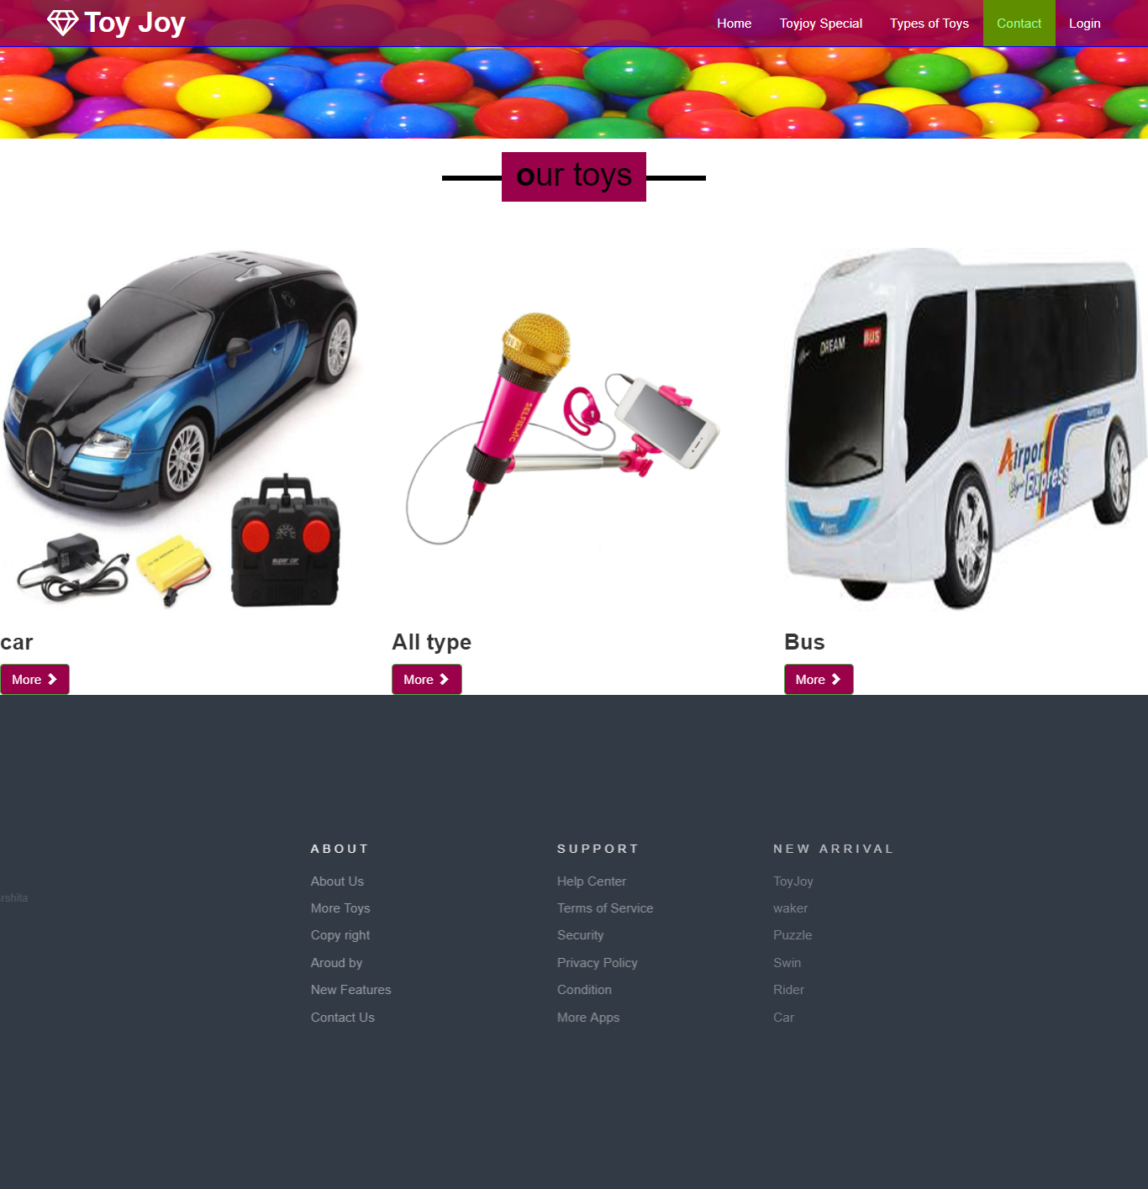

**Toy joy food toys**

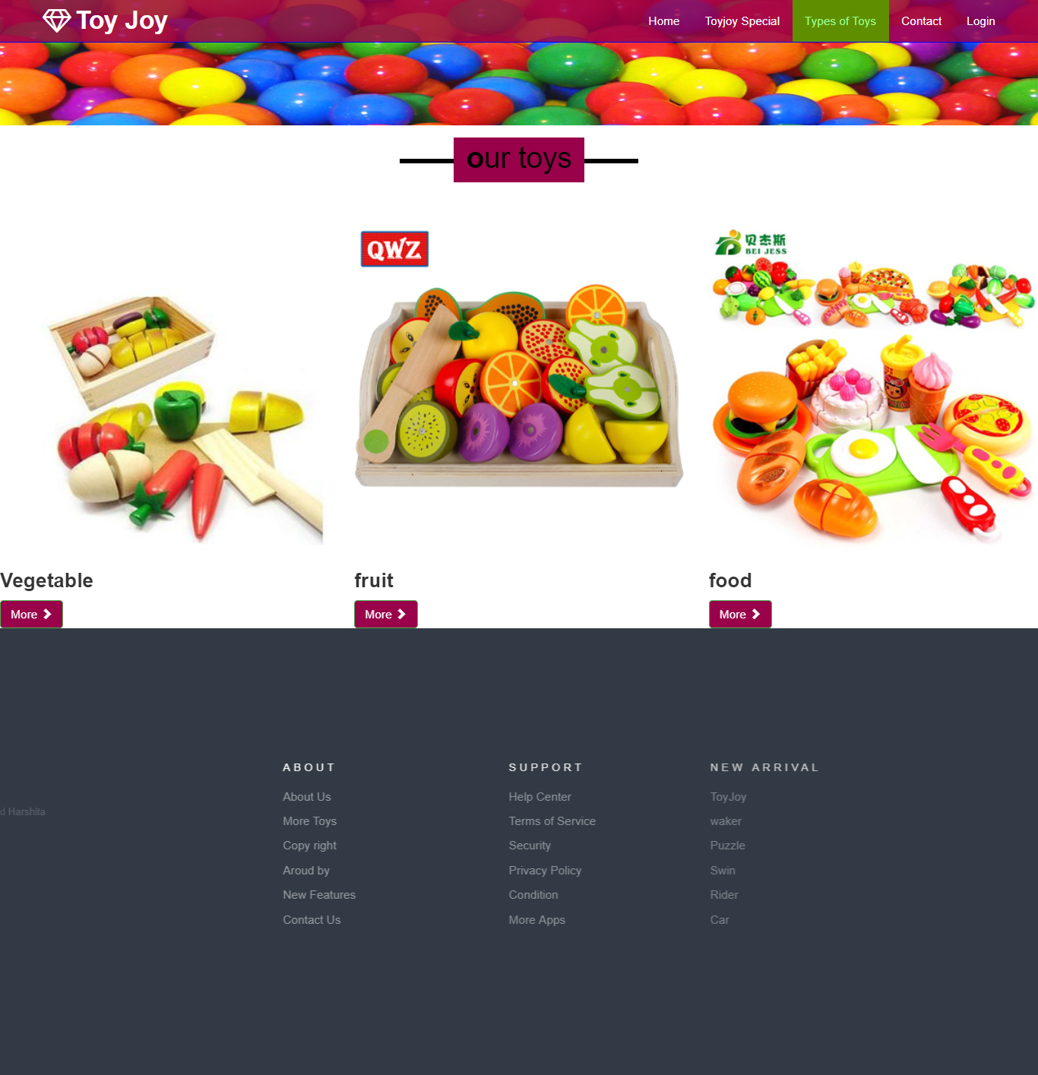

**Toy joy brain toys**

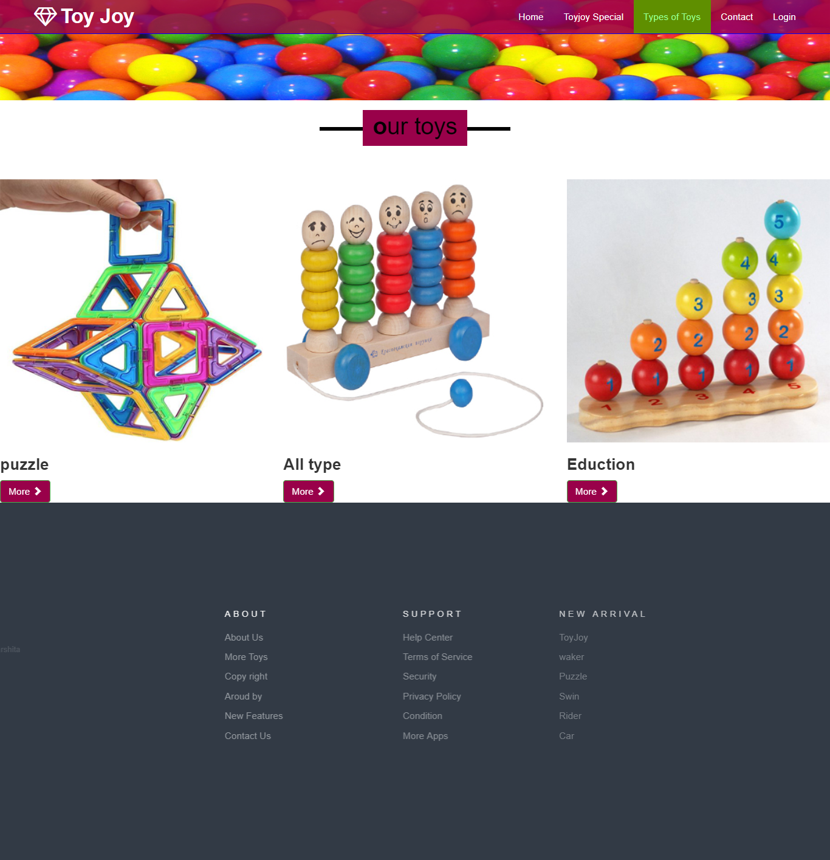

**Contact**

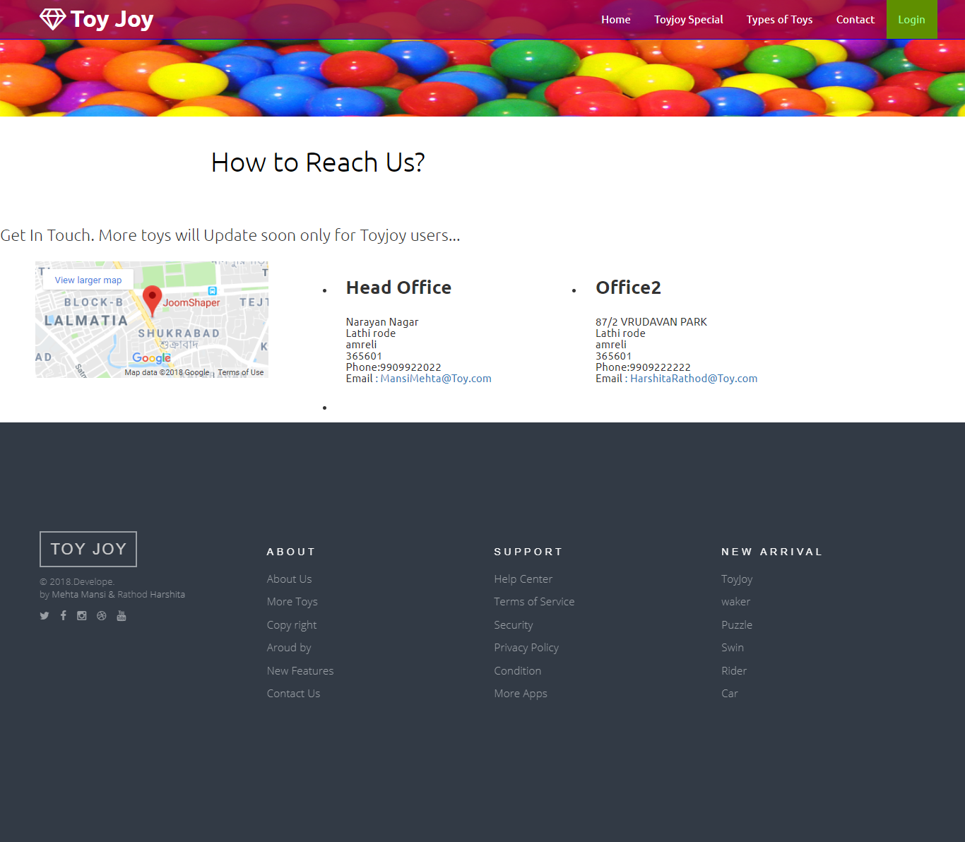

**User login**

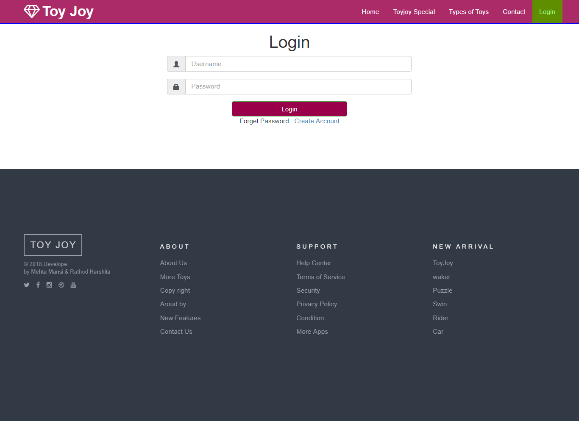

**Register new user**

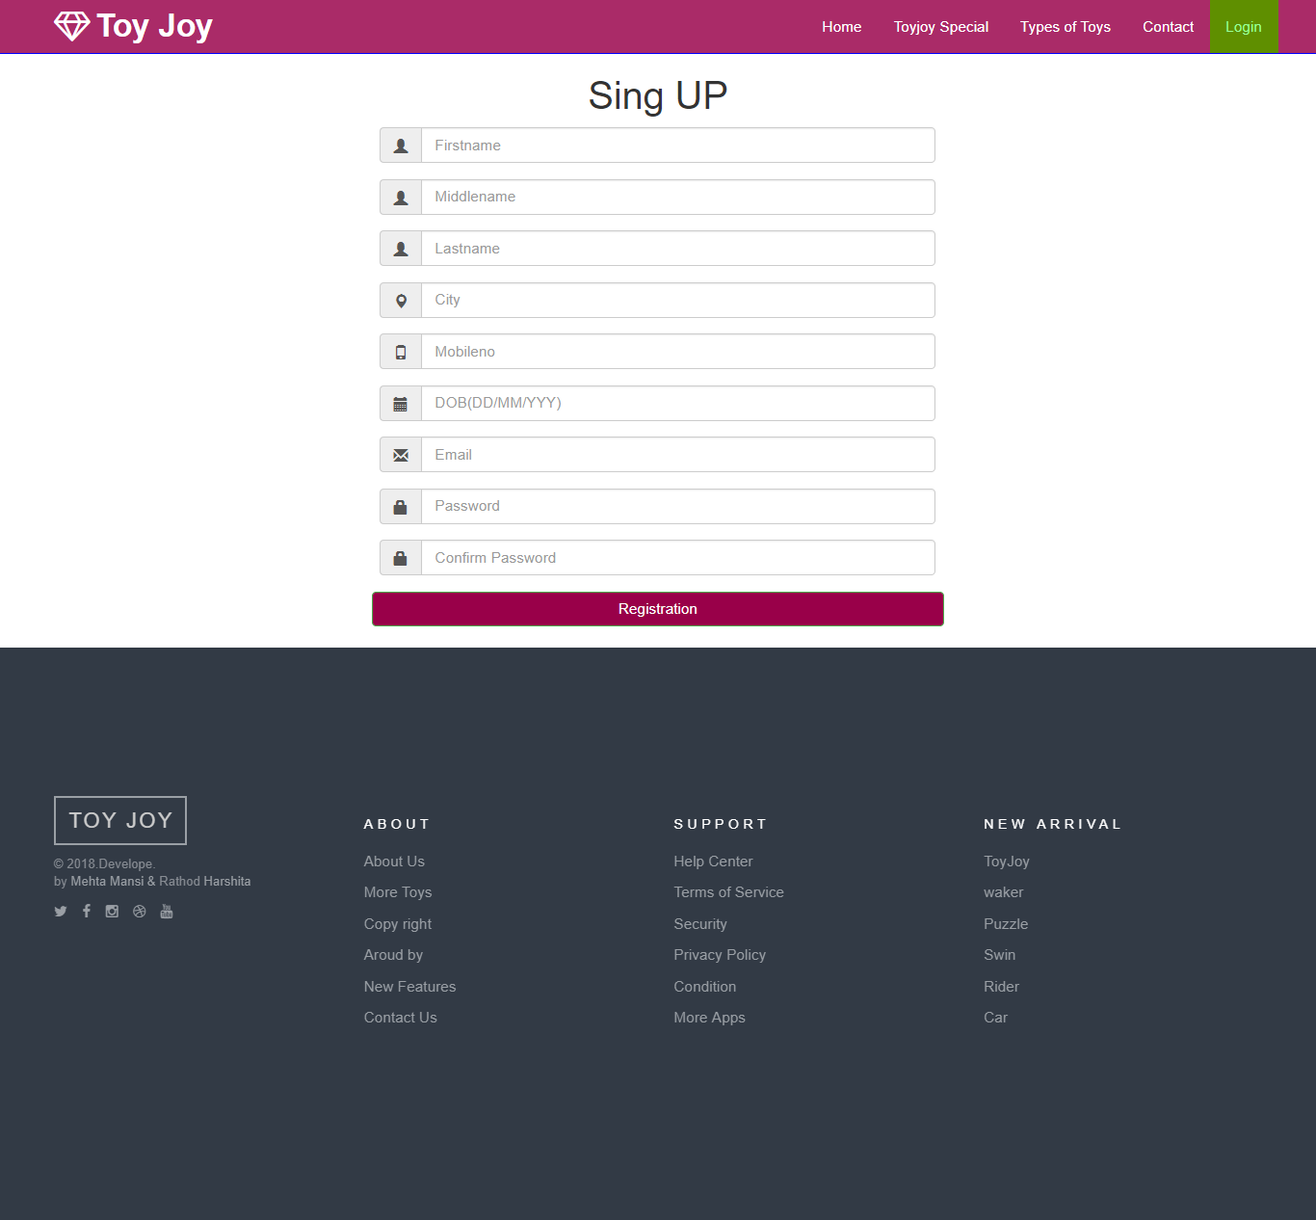

**After login home page**

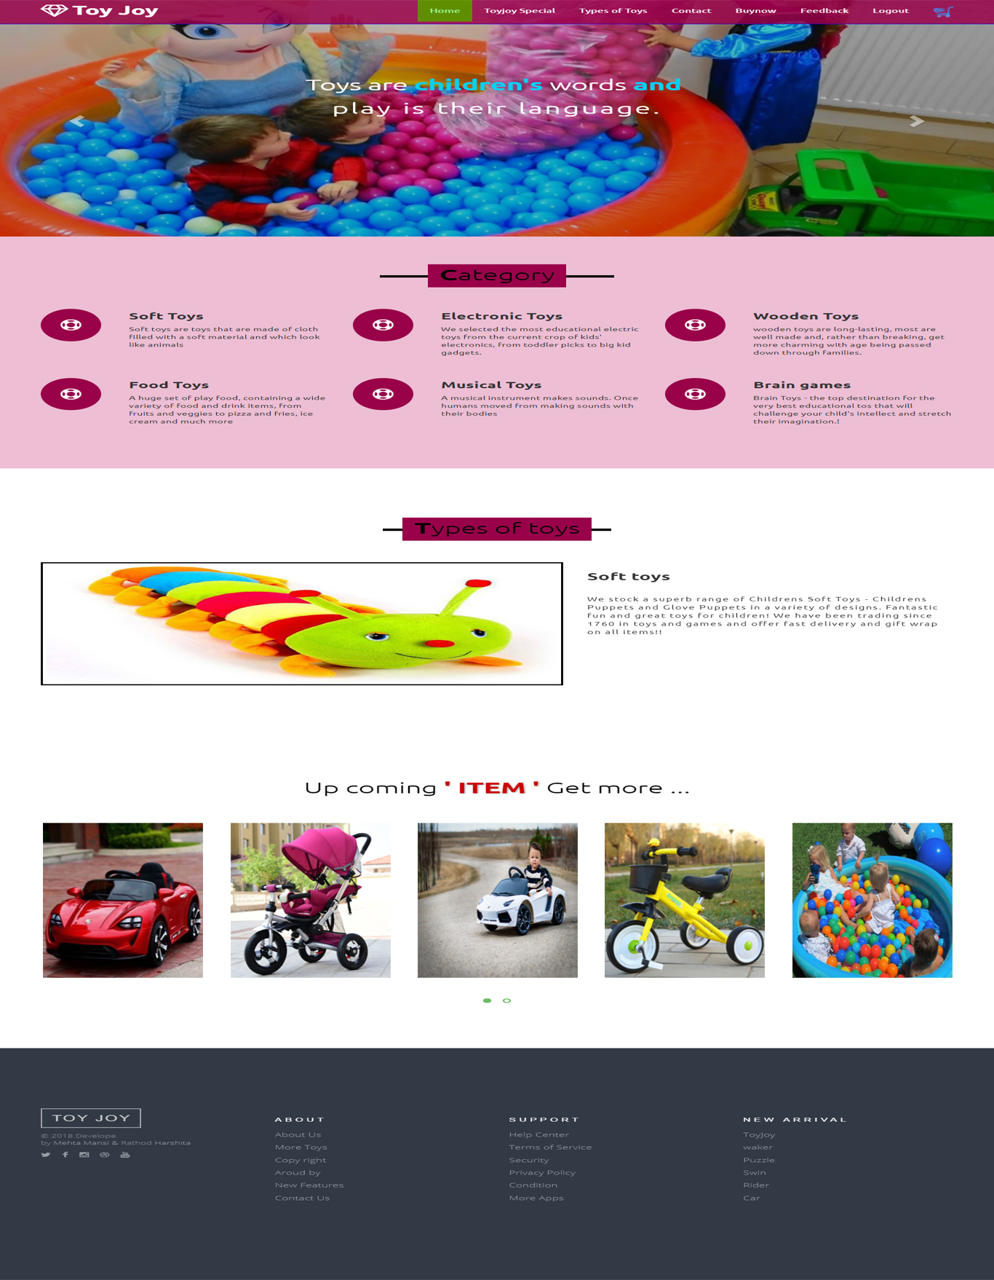

**After login toy joy special**

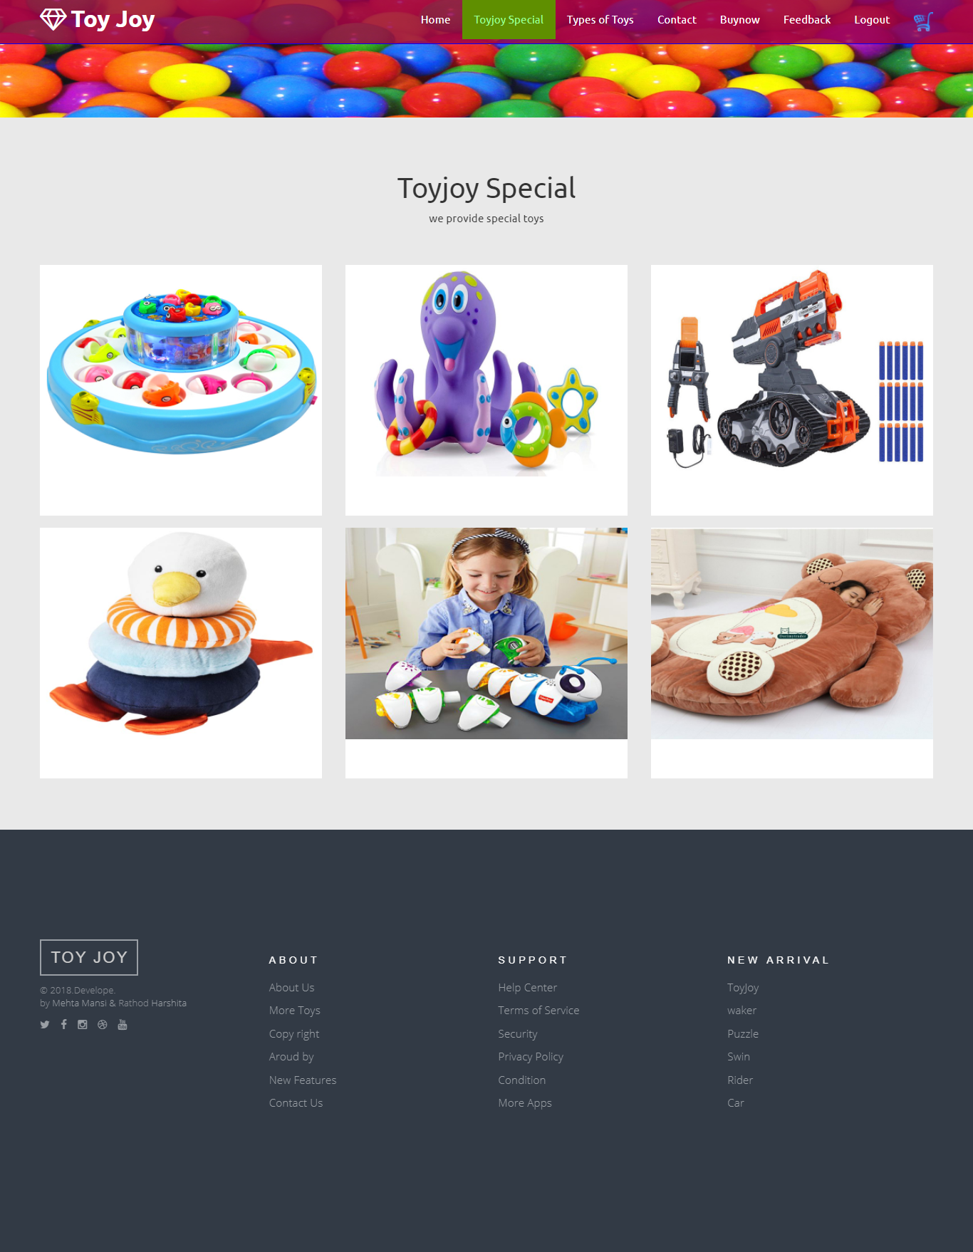

**Buy now**

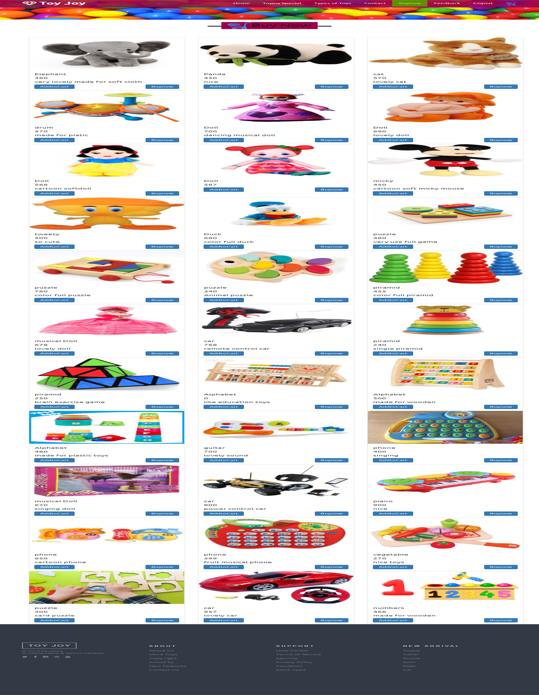

**View cart**

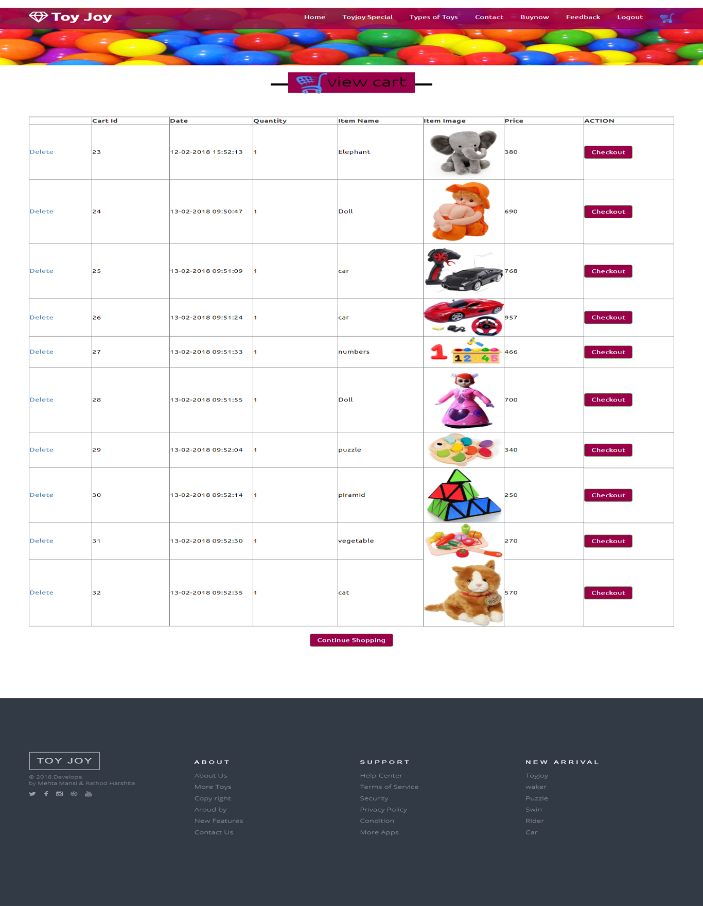

**Checkout**

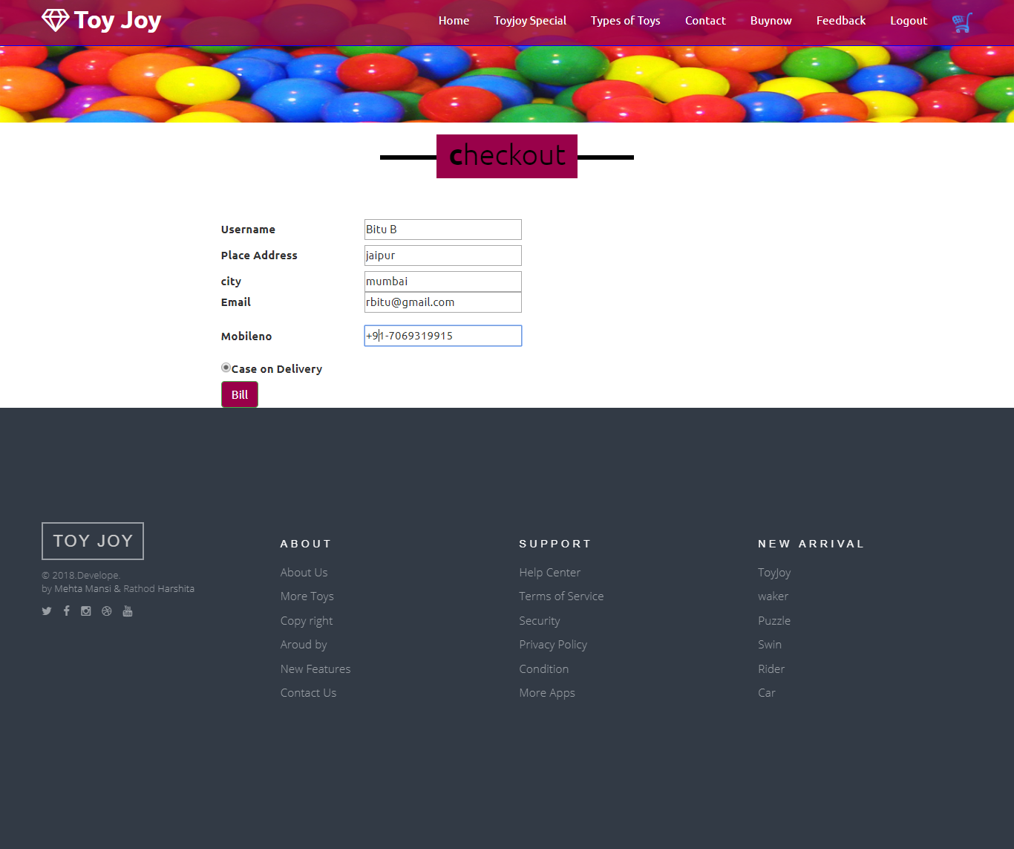

**Bill**

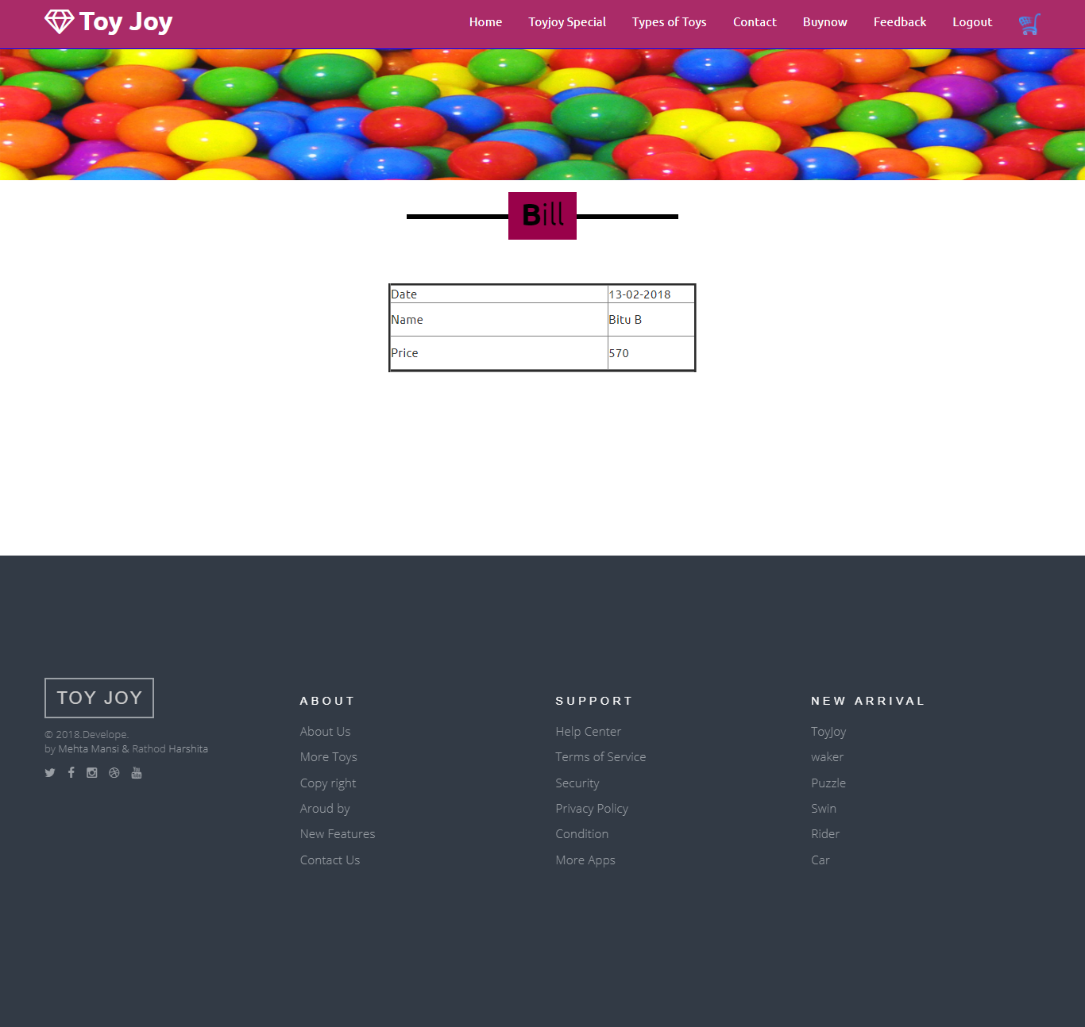

**Drop your message**

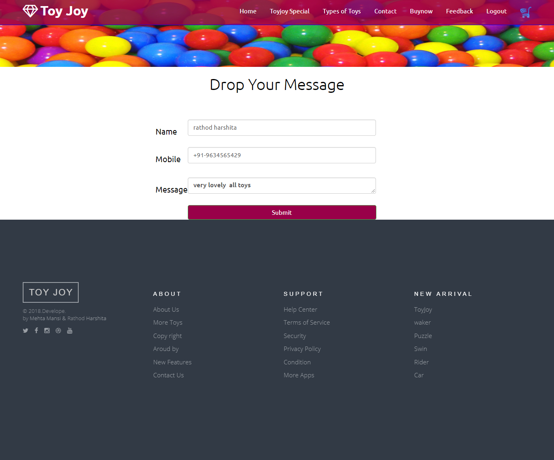

**Admin login**

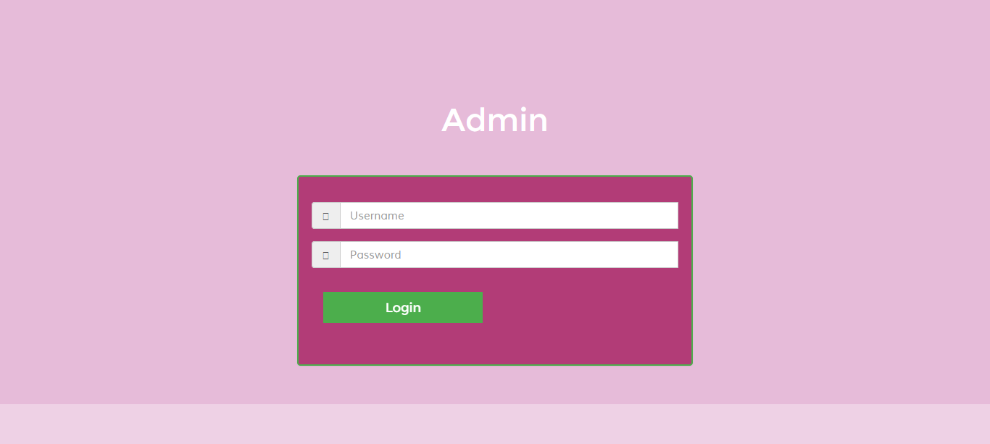

**Show users**

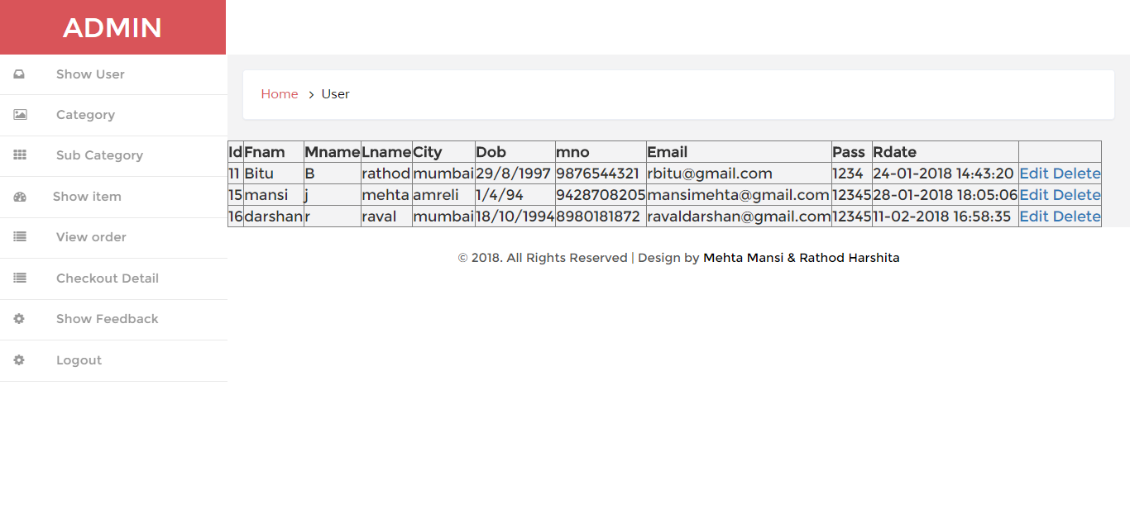

**Add new category**

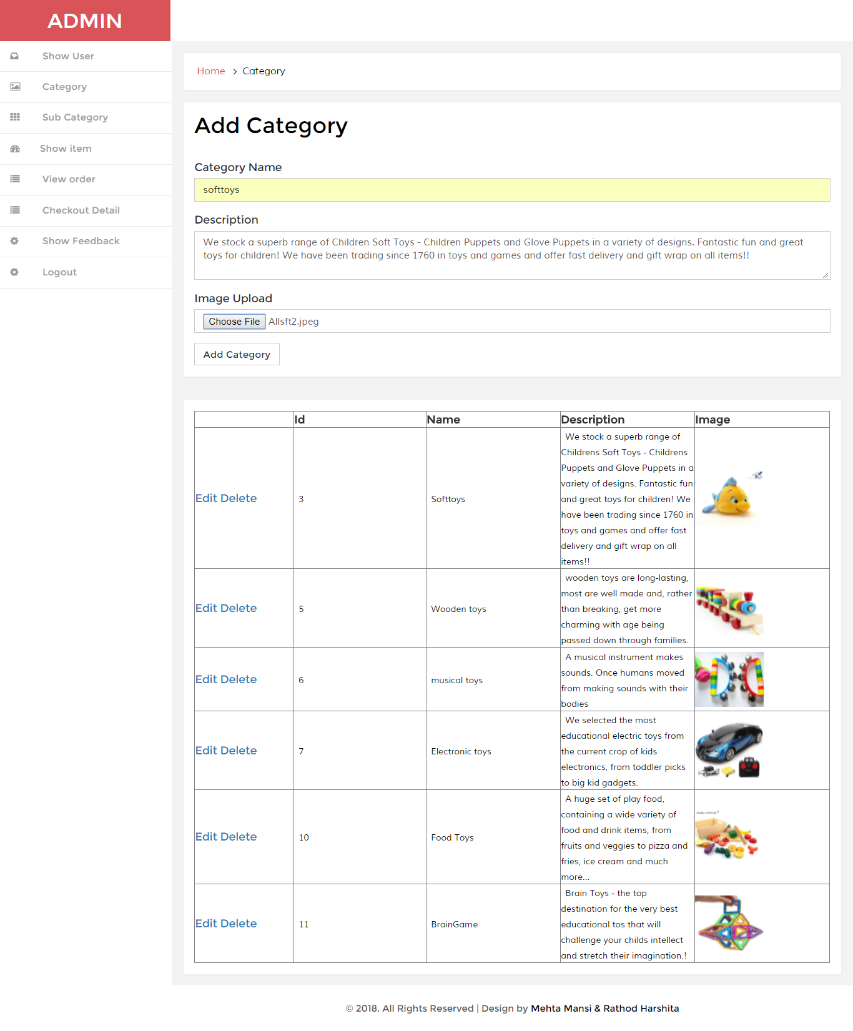

**Add new sub category**

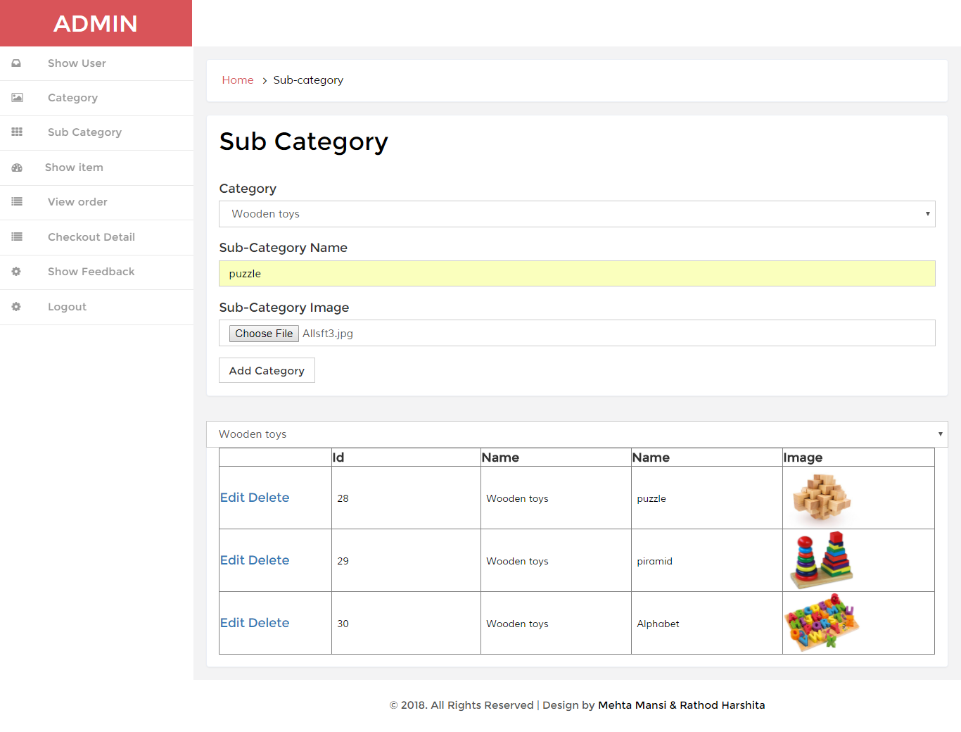

**Show item**

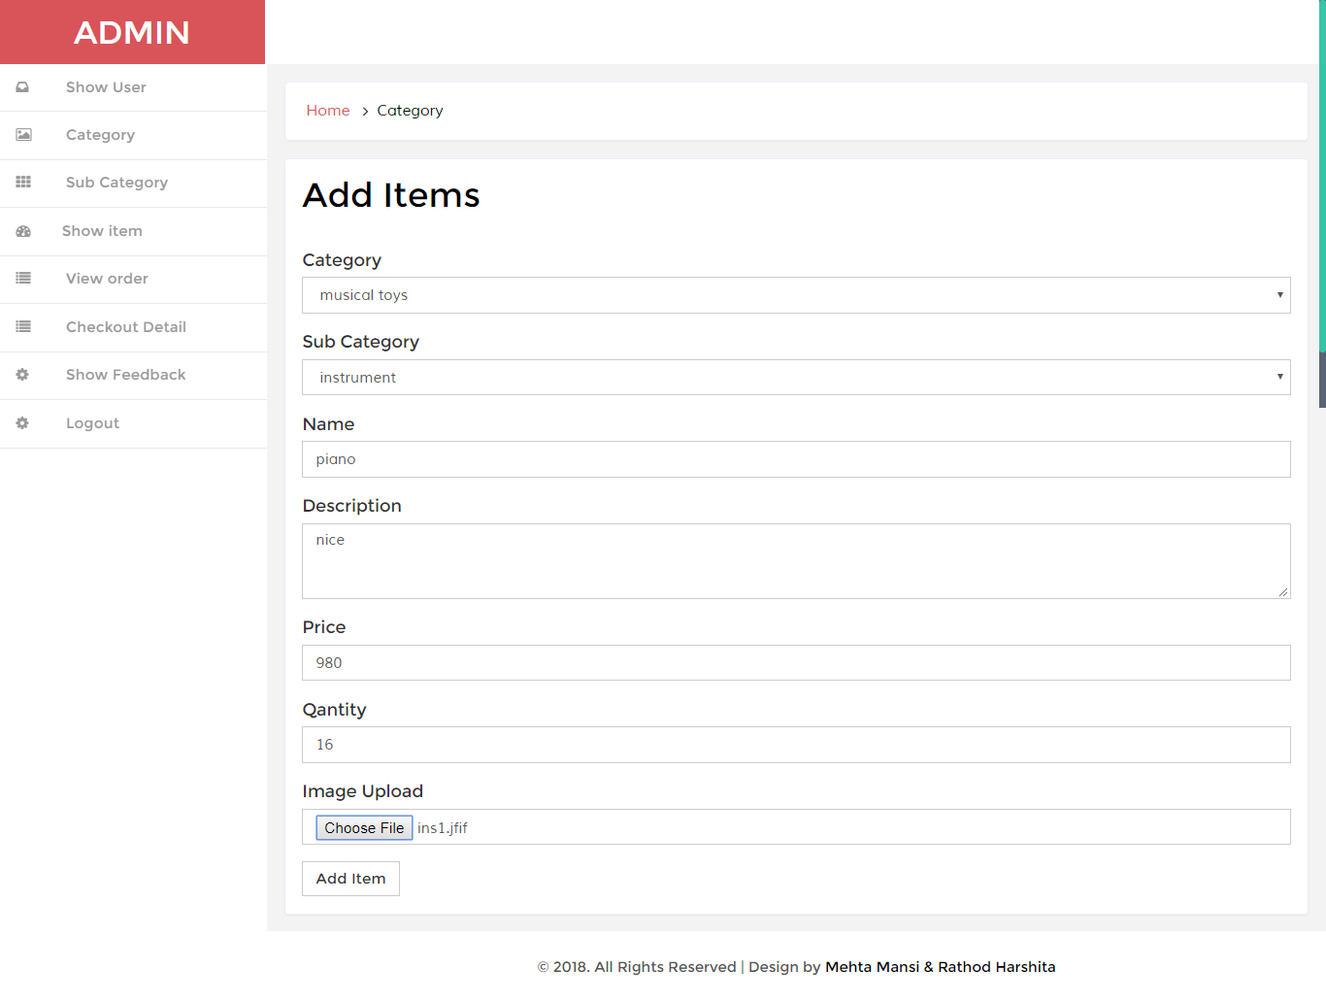

**View order**

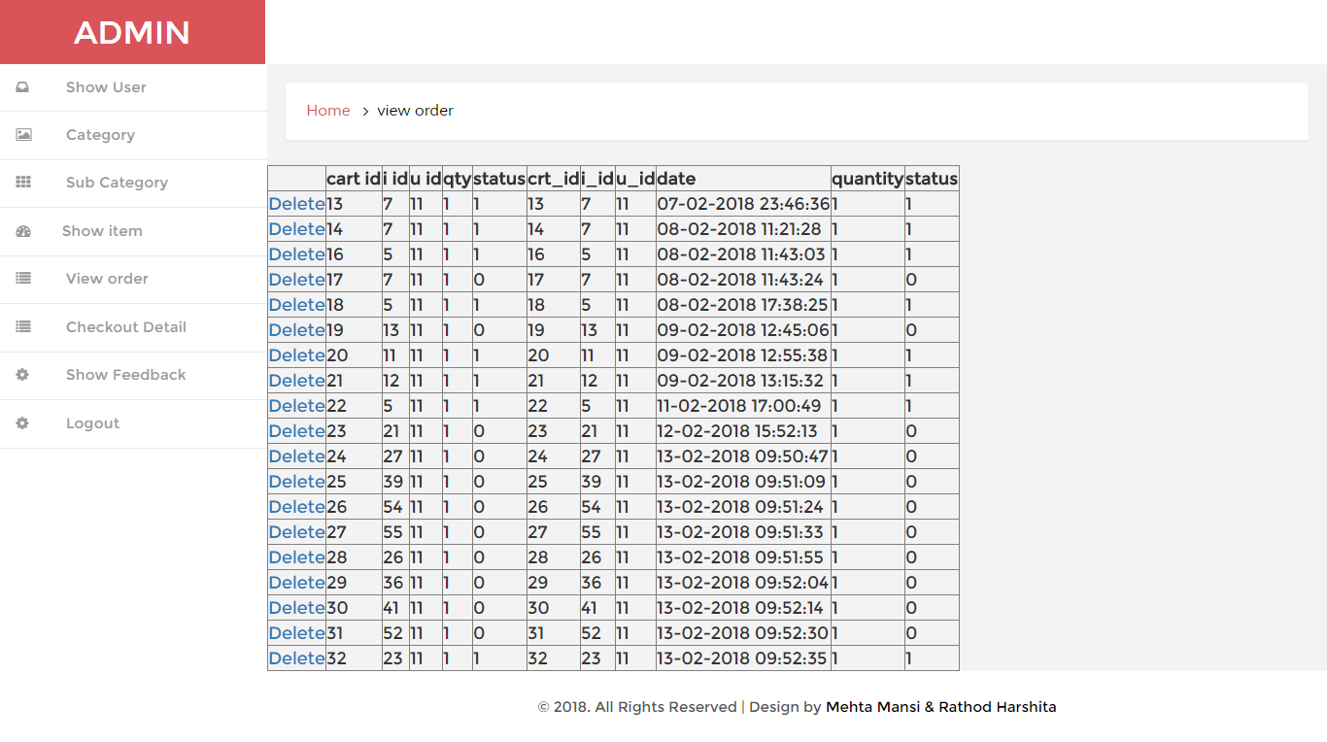

**Checkout details**

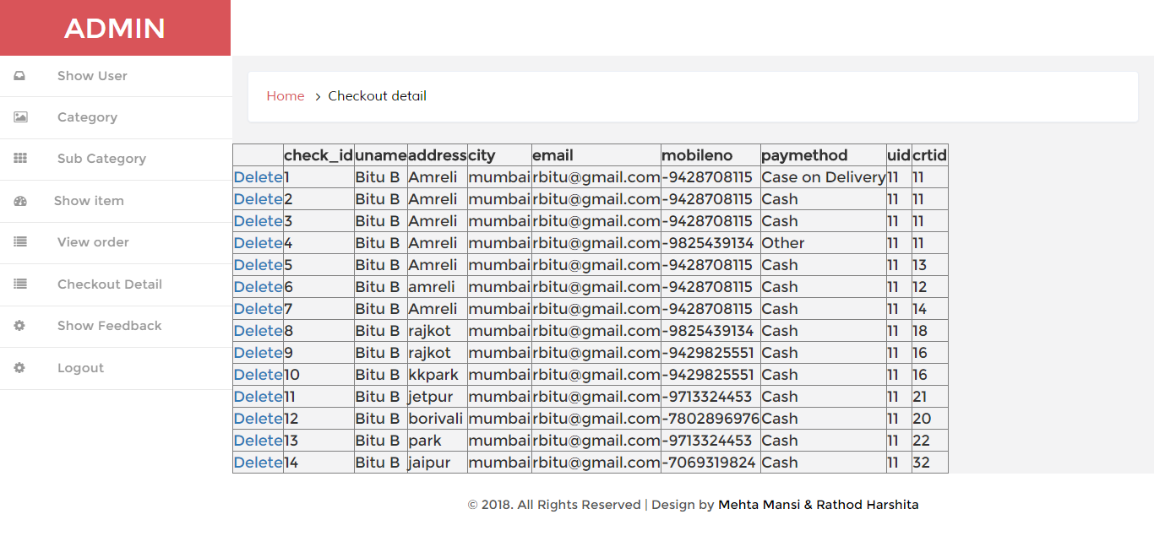

**Show feedback**

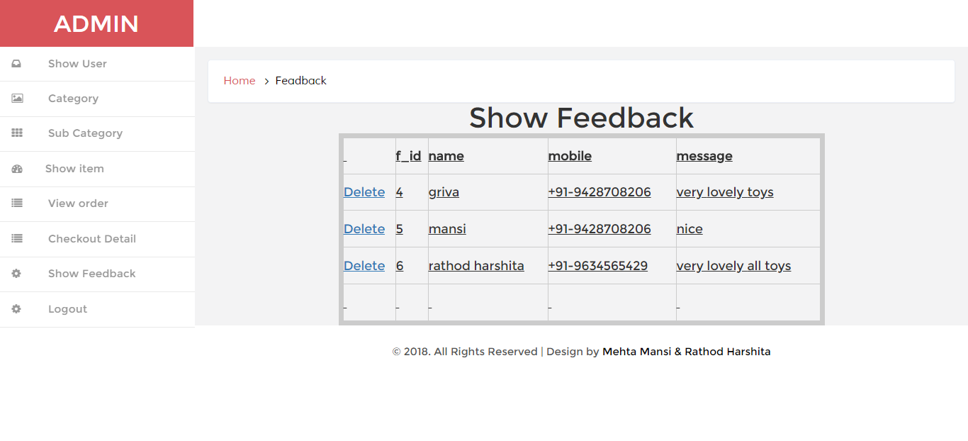

BIBLIOGRAPHY

For the successful working of my project we have referred many sources for the code snippets, logics and tips n tricks form the various books as well as web sites.

Most I searched for the required possessions on the google.com search engine. Many of the logics in my projects are used from the free code listed on the web pages.

* Books Referred:-

1) Asp.net 3.5 website programming

2) Programming Microsoft Asp.net step by step

3) c. jamnadash asp.net book

* General information

1. Google.com
2. W3school
3. firstcry.com
4. flipcart.com

